Processing pipeline:
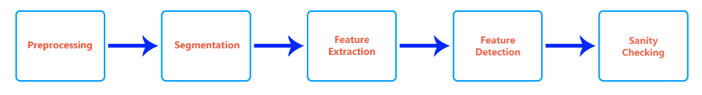

Preprocessing:
The program starts off by loading an image into the ‘Picture’ class, where a gaussian blur and median filter are applied. The median filter is used to remove any noise within the image while the gaussian blur is used to smooth the image out. While the gaussian filter smooths the high frequency noise, it also smooths the edges, which can increase the possibility of missing weak edges as well as creating isolated edges, depending on the inputted sigma value. To find the right sigma value to use with each separate image, the segmentation part (discussed in the Segmentation section) was run with increasing values of sigma ranging from 0 to 2.5, incremented by 0.25. The sigma value that produces the most amount of ‘identified’ labels is then used. Although this method does increase the probability of false labels being identified (through testing this probability was found to be low, with 3 false positives over 40 images containing approximately 90 labels), it was decided that this method was suitable as it was easy to implement and rarely missed any labels (1 label was missed out of approximately 90, however this label was partly outside the photo). Any mistakenly identified labels were to then be sanity checked later in the program. No colour balancing filters/effects were used as no computationally efficient effects were found that worked regardless of the image context. More on the reason for this is discussed in the Colour section of Feature Detection.

Segmentation:
The ‘picture’ class then applies a Canny edge. It then uses OpenCV to find all external contours within the image. The contours are then approximated to polygons and any contours that have an area less than 10000 (100pixels * 100pixels) or do not contain 4 points (clearly defined quadrilateral) are removed. A mask for the label is then generated and applied and the label is extracted to a 500x500 image via a perspective transform. A perspective transform was used rather than an affine transform as parallel lines were not required to stay parallel, as well as there was no guarantee what angle the image would be taken at. These labels were then loaded into their own ‘Label” class which would preform the label specific feature extractions/detections.

Feature Extraction and Feature Detection
Colour
The colour extraction and detection were preformed simultaneously. For both the bottom and top of the label, the colour at 20 points were taken and the most common colour was selected. Four equidistance lines of points were used, with each line having five points spread out equally, as seen in Figure 1. This method was used rather than a regular area as it proved to be more consistent as the colour with the most area is not always the dominant colour (as may be the case in Figure 2, where black would have a similar area to white in the top half). The image was converted to HSV and the colour was selected based on the values in table 1 in the appendix. As no colour correction was preformed (described in the Preprocessing section), images with inconsistent lightening were not normalized, causing some difficulties in the colour detection. The threshold of the V channel for the colour black was left intentionally low to allow for correct colour identification in shadowed environments, however this was at the expense of incorrectly identifying black in bright scenes. It was decided that this was a compromise to be made as it only incorrectly identified a colour in a few instances and the time required (both computational and coding) was not worth the marks lost. In a real life scenario this would not be too much of a problem as there would be other sanity checks to determine the colour however no such checks were used in preparation of the bonus stage.
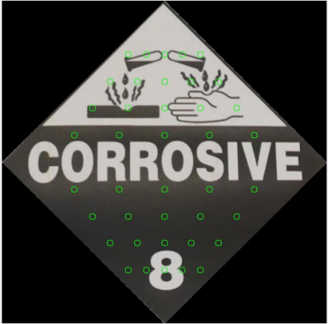
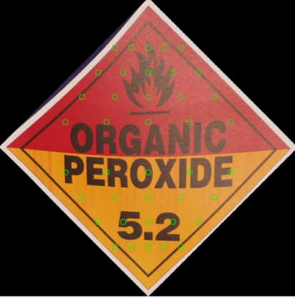

Figure 1. Points used for colour detection. Figure 2. Its possible the top half had a greater
amount of black pixels compared to white.

Text and Class Number
The text and class identification were both preformed by Tesseract, however a lot of feature extraction and processing was needed in order to get it in a format that Tesseract would be consistent with. The label was converted into HSV and the V channel was extracted, where an adaptive threshold was then preformed on the channel in order isolate the text and class number, with the results shown in Figure 3 and 4. This was able to isolate both black and white text, as black text always had a lower V value than the surrounding pixels and white text always had a high V value compared to the surrounding pixels (which required us to invert the image in the case of white text, as seen in Figure 4). The window size and the constants used for the adaptive threshold were empirically determined, needing to be big enough to remove noise but small enough to still identify the letters/numbers. An adaptive threshold was used rather than a regular threshold as the V value required would change based on the image.
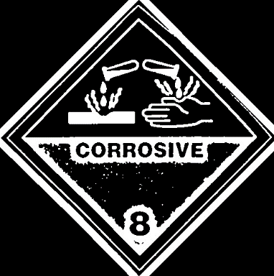
Figure 4.
Invers of the adaptive threshold on the image in Figure 2
Figure 3. Adaptive threshold on the Image in Figure 1.

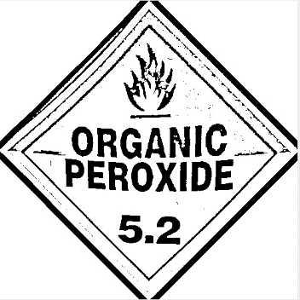


Opencv’s simple blob detector was used to determine all blobs that fit the description of a letter/number (the parameters can be seen
in Data/blob.xml) and each letter was extracted. The simple blob detector was used over MSER as it was slightly faster and it was Figure 5. An example of an extracted text
found that MSER provide no benefit in testing. Some noise was
removed by checking the pixel density of each blob and removing outliers, while any other noise that made it through were either not picked up by tesseract or removed (as it would return special characters). The initial idea was to use Tesseract on each letter separately, however this was not computationally efficient as it took around 100ms for Tesseract to read an image of a single letter. Instead, blobs of similar heights and distances were spaced out and combined before being feed to Tesseract (Figure 5). This allowed for Tesseract to clearly identify each letter/number while still being computationally efficient. Tesseract was not perfect in its identification of words and spaces, however it was consistent enough that minimal sanity checking had to be preformed (which is described in the Sanity Checking section). The midpoint of this newly formed word was then checked to see if it was in a valid text position, class position or neither (which were just naïve rectangle crops).

This was done twice per label, once on the adaptive threshold (Figure 3) and once on the inverse of the adaptive threshold (Figure 4), as I was unable to find a way to correctly identify the colour of the text in a label before identifying the text. One way that was attempted was by using white and black histograms of the label, however this did not work well for labels with a black or a white background colour and as such it could not be used generally. I decided the best choice given the limited time was to do both and chose the one which best resembled a ‘word’/’class’. Although this may seem like an abstract and non reliable method, it proved to work extremely well with minimal tweaking. This part does not use a dictionary to sanity check the words, meaning it will still work on words that are not known (Stage 6). In most cases, no valid blobs were found on the incorrectly thresholded image (eg the inverse if the text was black). In the off chances that any text was found (approximately 10% of the time), it was easy to tell the difference as only a few strange characters would make it through. The exact process for determining the best word and class number is described in appendix 2.

Symbol
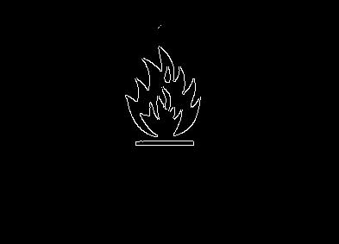
It stated that all labels would have a symbol, which made feature extraction easy as we could always assume there was a label. A naïve crop of approximately the top third of the label was done and the canny edge detector was applied (Figure 6). A naïve crop was done rather than a blob detection for two main reasons; not all symbols were the same colour and computational time was wasted on finding the symbol when the approximate location was already known (and unlike the text and class number, we knew that each label would have one). Shape context¹ was then used to match the symbol with any of the know symbols, which are contained in the ‘Symbols’ folder. The only difference with this implimentation of Shape Context is that it uses a greedy approach to find the minimum cost rather than the hungarian method, as well as the hungarian method being O(n³) while the gready approach is only O(n²). This was done as the implimentation of the hungarian method was extremely time consuming and the shapes were different enough that the greedy approach worked well. Although Shape Context was not as accurate as OpenCV’s Orb and Bruteforcematcher(~85% vs ~95%), Shape Context was chosen as it would be a much better fit for stage 6 as it works really well on images that are similar whilst Orb only works on images that are extremly similar. This is evident in the fact that the main error that Shape Context’s gets is incorrectly identifying Oxidiser and a flame (due to the naïve crop cropping out the bottom of the Oxidiser).
Figure 6. Canny edge detector preformed on a label with a naïve crop.

Sanity Checking
The final stage of the perception pipeline involves sanity checking the various components of the label. The basic premise of this stage is to make each element “Assignment ready”, such as putting spaces between words and slightly autocorrecting words. For the text, the first stage implements a slight autocorrect as Tesseract commonly misses one character/adds another. This is implemented by reading the file ‘Data\dictionary.data’ and checks to see if each word is contained inside the label text. The exact specifics of how this works is included in appendix 3. Spaces between words are then added and finally, proper formatting (such as turning NONFLAMMABLE into NON-FLAMMABLE) is applied. The found symbol is also properly formatted.

